**Impossible burger Sentiment Analysis**

**Introduction**

Impossible Foods Inc. is a food-company that develops plant-based substitutes for meat products. Their motive is to offer a healthier and environmentally friendly alternative, while attempting to retain the taste, texture, and nutritional benefits of meat. The signature product of the company – the “Impossible Burger” – was released into the market in 2016. Since then, many burger joints have had a keen interest in incorporating the burger into their menus as an option for vegan and vegetarian consumers. In an attempt to expand Burger King’s consumer base and entice more vegan, vegetarian, and flexitarian (those who are trying to reduce their meat intake) consumers, the burger joint added the ‘Meatless Impossible Whopper’ to its menu in more than 7000 locations across the United States on August 8th, 2019.

Beyond Meat, a direct competitor of Impossible Foods Inc., has a similar product called the “Beyond Burger”, which has been rolled out in joints such as Carl’s Jr. and Subway. Vox, a digital media and news platform, recently published an opinion piece on the backlash that the meatless burgers are receiving, on October 7th, 2019. In the article, they cited that the response to the meatless burger has not been all positive despite its good intentions. Many consumers have voiced their opinions on the meat-alternative being too processed, not quite healthy, and an inauthentic take on a classic veggie burger. However, the article also highlighted the positives of the burger, stressing on its similar resemblance and taste to meat.

Given the exciting market for meat alternatives, we were interested in exploring the different positive and negative sentiments for the impossible burger based off twitter posts. We anticipate that a lot of tweets will focus on the Vox article and the “Impossible Whopper” at Burger King, given the recency of both those releases.

**Data Cleaning**

Once we extracted 1200 tweets from Twitter and saved it as a csv, the first step in the data cleaning process was removing any special characters from the tweets, such as symbols and emoticons, as they cannot be inputted in our sentiment analysis. After creating corpus of all tweets, we converted all text to lower case, removed all punctuation, numbers, stop words and URLs from the data. We then removed any “Impossible Burger” word variants and white spaces. We then created a term document matrix, consisting of 2509 terms and 1200 documents, to enable us to visualize the cleaned data and draw insights from it.

**Text Analysis**

To begin our analysis of impossible burger tweets, we first created visualizations of the most popular words and recorded them in a bar plot and world cloud.

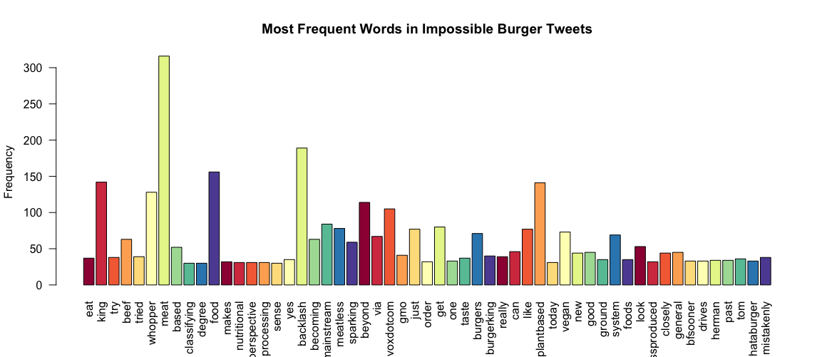

Figure 1. Bar Plot of Most Frequent Words for Impossible Burger Tweets

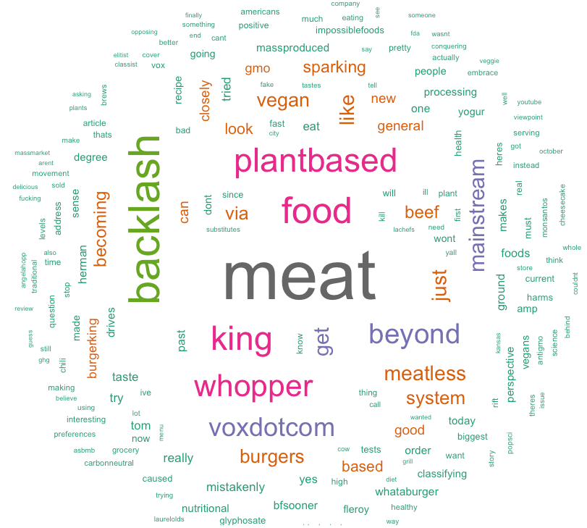

Figure 2. Word Cloud of Impossible Burger Tweets

Figure 1 and 2 both illustrate that the word most frequently mentioned is “meat”, which is ironic considering that this product is meant to be a replacement for traditional meat. In addition, the word backlash is mentioned quite a bit, which is tied to the negative opinions and many articles that have recently arisen to discuss the consequences and hostility toward Impossible Food. In fact, the word “backlash” also relates to "voxdotcom”, which is the twitter account of the popular online media company *Vox.* Their tweet and accompanying article (the word “mainstream” is also a part of the article title) have been retweeted by countless people and represents a node with a high degree in our relationship model show below.

“King” and “whopper” are connected to Burger King’s recent release of the “Impossible Whopper”, which has garnered a lot of publicity. Beyond Meats even gets a shout out, as “beyond” is another popular mention in tweets, most likely by people who are comparing the different meat substitute brands.

Other popular words such as “plant based”, “meatless”, “vegan”, “beef”, etc., are common descriptors or associating words with the impossible burger. Even more words seem to allude to people’s comments after trying the impossible burger for themselves, or the issues of questionable health of this scientifically engineered food.

**Sentiment Analysis**

To test the sentiments of those tweets regarding the impossible burger, we ran a sentiment analysis on all the collected data.

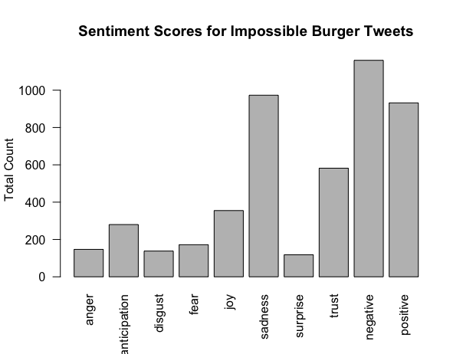

Figure 3. Bar plot of Sentiment Scores for Impossible Burger Tweets

As one can see, there is a significant count of tweets that negative, positive, or sad sentiments. The fact that negative sentiments make up the majority is interesting because it shows that despite Impossible Foods’ image of creating a healthy, more sustainable alternative for meat that preserves the look and taste of the original, people still are suspicious of the product and it has faced harsh criticism in the twitter population. The high count in the positive column also poses an interesting finding as it shows that the issue of meat substitutes is very polarizing and people are not afraid to share strong positive or negative opinions. In addition, though the negatives are high, trust also represents a larger category which means people likely are vouching for the taste and nutrition of the new food. The impossible burger is a pioneer in revolutionizing fast food chains and the way the everyday consumer considers protein, so it is not surprising that there is controversy in opinion.

Given that the impossible burger was recently released in fast food chains across the US, it makes sense that anticipation, joy, fear, and surprise also represent a portion of the analysis; these are most likely comments discussing the desire (or lack thereof) towards trying the new burgers. However, one category we found particularly interesting was “sadness”. At first, we weren’t sure what to make of the high count, but after further examination it seems tweets categorized as “sad” tended to reference the potential health issues related to this new meatless burger—GMO’s, chemicals, and other hazards are at the forefront of people’s minds as they cautiously consider fake meat. For example, this tweet had the highest report of “sadness” at a rating of 3: *“Lab-grown foods like the Impossible Burger represent the ultimate conflict in health information: We're told that plant-based diets are healthy, but we're also told that processed foods are unhealthy.”* The threat towards human health and the “conflict” that arises from this product are likely the cause of the categorized sentiment for this tweet.

Here are some other examples of tweets:

*"I don’t eat meat but you’ll never catch me getting that impossible burger from Burger King. Hell no"*

This tweet had mixed sentiments with anger, disgust, fear, sadness, surprise trust, and negative and positive feelings attached to the meaning, which is intriguing.

*"Meatless meat is becoming mainstream — and it’s sparking a backlash...”*

This tweet, on the other hand, has no sentiments recorded as all, potentially because it is not an opinionated post but rather referencing the article posted by *Vox*.

**Network Clustering**

**Word-Related**

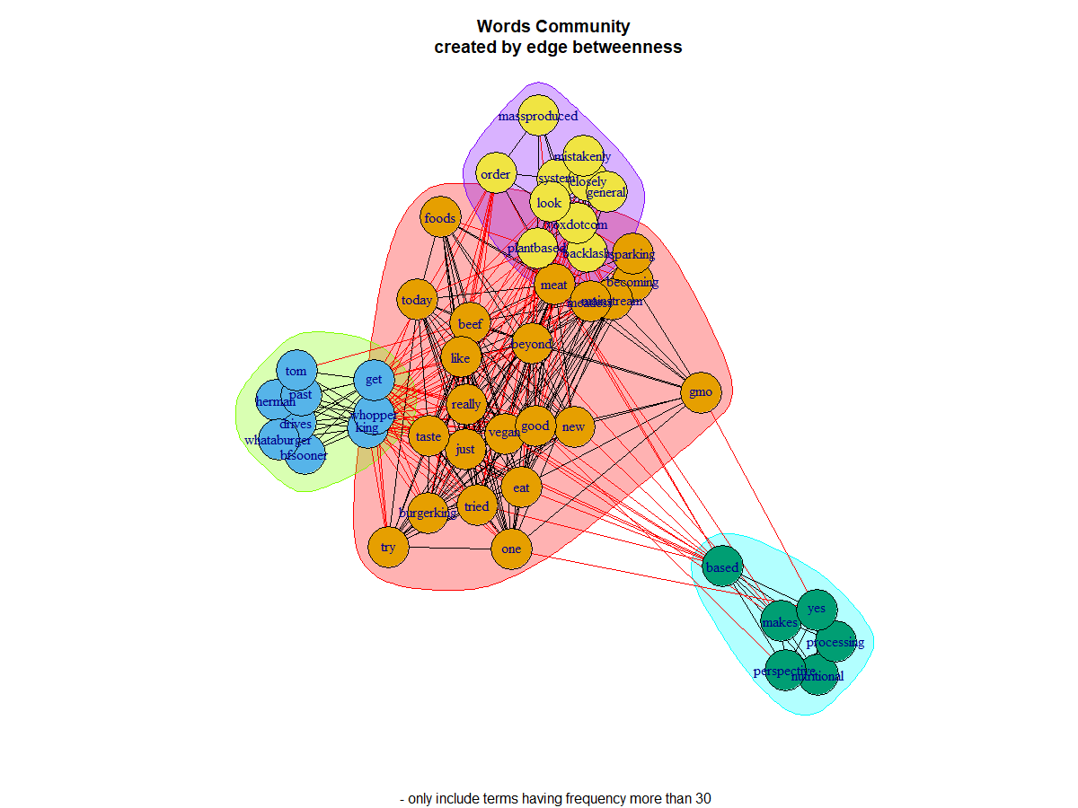*3 Community Creation Method*

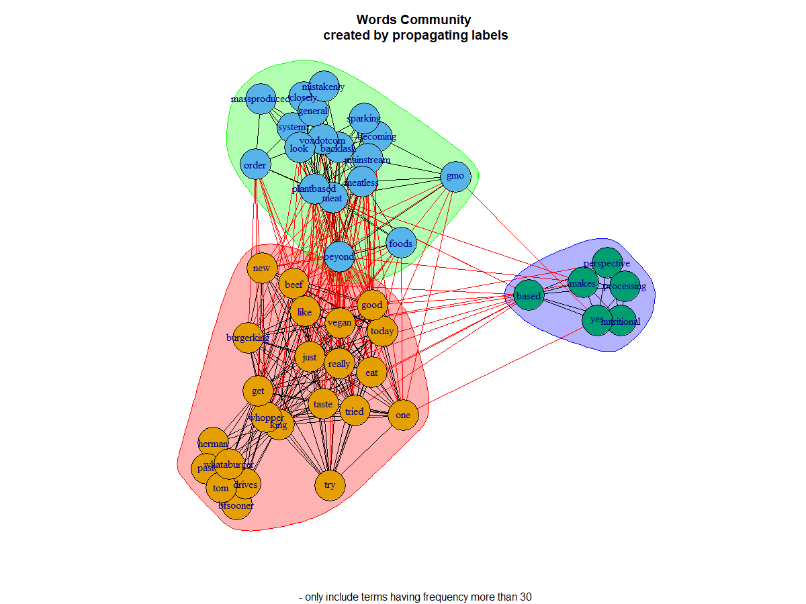

Figure 4. Words Community Created by Edge Betweenness Figure 5. Words Community Created by Labels Propagation

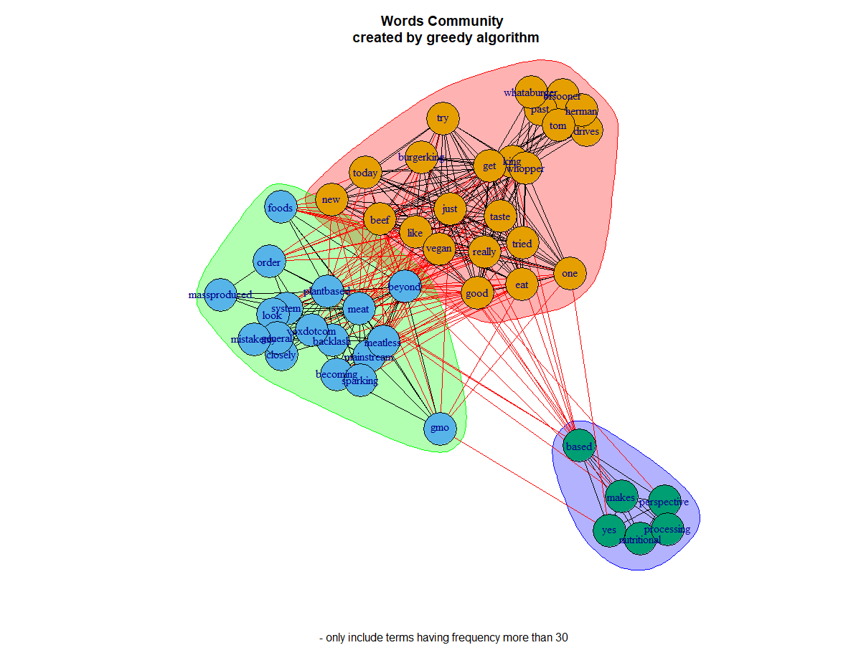

Figure 6. Words Community Created by Greedy Algorithm

We applied three clustering technique to categorize the word data into potential community among words. While the edge betweenness approach produced a slightly different result as compared with the label propagation and greedy algorithm approach, the overall themes of each word cluster remain similar among the three-community creation method.

Referring to Figure 6 and 7, the “red” cluster contains words such as “burgerking”, “whopper”, “good” and “tried”. This group of words are related to customers’ positive comments on Burger King’s recent release of “Impossible Whopper”. We define it as a “positive community”.

The “green” cluster, containing words such as “Voxdocom”, “gmo”, “backlash” reflects the questioning voice and concerns on impossible burger. Thus, we define it as a “negative community”.

The “blue” cluster which is smallest cluster among the three includes words such as “nutritional” and “processing”. This cluster provides us with the information that customers pay a significant amount of attention on the production process of the impossible burger.

The network clustering analysis shows that people have controversial views toward the idea of impossible burger. Such result supports our insights obtained from the sentiment analysis where we observed a high level of both positive and negative sentiment.

**Tweet-Related**

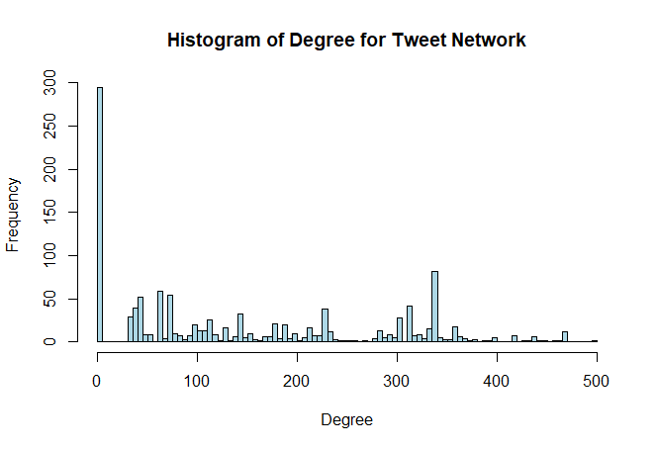

Figure 7. Histogram of Degree for Tweet Network

Overall, the distribution of the degree for tweet network is highly right-skewed. Degree is a metrics used to measure how many edges connected with a node. In our case, degree indicates the number of re-tweets for a single tweet. According to figure 8, we can see that the majority of these 1200 tweets are not connected with another tweet, indicating that most of the tweets didn't get re-tweeted. Besides, we noticed that there is a gap between 0 degree and 20 degrees. It means that if a tweet got re-tweeted, then it's very likely to get re-tweeted more than 20 times. Moreover, it’s interesting to find that for those tweets that got re-tweeted, the general distribution follows a uniform distribution with lower bound of 20 degrees and upper bound of 500 degrees. Therefore, if we want to increase the influence of our tweets, the first and also the most important step is to get re-tweeted by other people.

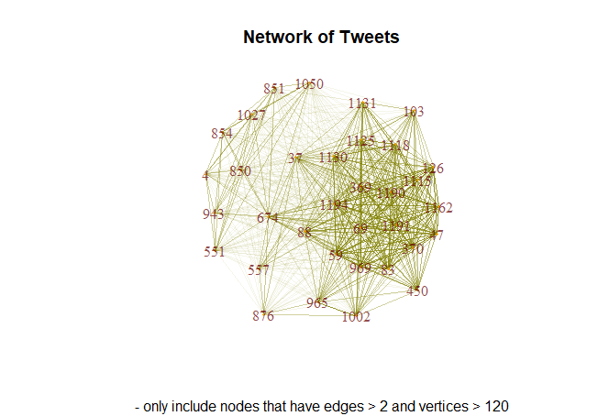

Figure 8. Network of Tweets

Figure 8 shows the network of tweets. In this graph, we only included nodes that have more than 2 edges and have more than 120 vertices. We noticed that tweets #1190, #1191, and #1194 are highly corelated. Thus, we retrieved these 3 tweets and found that all of them linked to the same article called *Plant-based 'meat' is conquering fast food. Here's where you can get meat substitutes like the Beyond Burger and the Impossible Taco.* The posters of these tweets are all have 17.6K, 899, and 19.7k followers respectively. They are opinion leaders on the Internet and all of them shared the same article with the same comment at the same time. Therefore, it's not difficult to see that the author or the publisher of this article may hire these opinion leaders to share this article, so that people are more likely to notice, read, and share this article. The fact is that by doing so, these tweets are indeed highly connected with the other tweets and got re-tweeted multiple times. So, in order to increase the online influence of an article, cooperating with opinion leaders may be a good strategy.

**Conclusion**

In summary, there is much knowledge to be gained by studying text, sentiment, and clustering analysis regarding a particular product. Impossible Meats represents a frontrunner in a revolutionary industry, but there are still many who doubt or even fear and hate the idea of the impossible burger. Impossible Foods should consider focusing on their brand image and the nature of their meat in marketing campaigns to decrease the skepticism towards their food and increase positive sentiment. If these meatless meat companies can manage to debunk the negative myths surrounding their food products, they soon may become a regular staple in all restaurants, as well as consumer homes. Speaking from experience, it’s *impossible* to tell the difference.